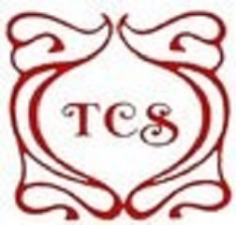
Come and Sing!
Teddington Choral Society

Music Director: Sam Evans
Accompanist: Phil Culling
Vocal Coach: Kerry McDonnough
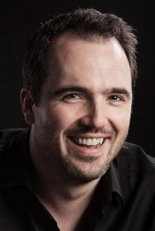 | 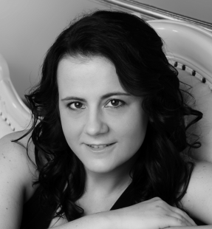

Saturday 23rd September 2017
Vocal Workshop
Using Two Haydn's Masses & Christmas Music*
1:1 Singing lesson sessions available with Kerry McDunnough

Teddington Baptist Church, Church Road, TW11 8PF
10:00am registration. 10:30am-Lunch-5pm.

£15 for TCS members, £20 for non members & £25 for lessons.
…………………………………………………………………………………………………………….
REGISTRATION FORM
FirstName ................ Last name:...................... Phone number ................

Email address ..................................................................................
Voice part: Soprano Alto Tenor Bass

Tick for Hire Music Yes-Small returnable deposit required * St Nicholas & Theresa Masses & Carols For Choirs 1 OUP
Book the Workshop & Lessons via
- TCS Website http://www.teddingtonchoral.co.uk/

    - E: infoteddchoral@gmail.com

    - Post Jean Leonard, 19 Tudor Gardens, Twickenham TW1 4LE. Enclose a stamped self address envelope if you require a receipt.

Cheques Payable to Teddington Choral Society
Musical Director: Sam Evans.Sam is a professional singer, conductor and teacher. He is Music Director of Thomas's Choral Society in Battersea, Artistic Director of Riverside Opera, and has recently been appointed Choral Director at Reading University. He received his early musical education in the choirs of Tiffin School and Kingston Parish Church, and took up a choral scholarship at King’s College Cambridge in 1998. He has sung regularly with the Monteverdi Choir since 2001, and has performed with all the major professional UK choirs, including Polyphony, The Sixteen and the BBC Singers. As a soloist, he trained on the postgraduate singing course at the Royal Academy of Music, and later at the Royal College of Music International Opera School, graduating in 2011 with the prestigious Tagore Gold Medal. Solo engagements have included Mozart Requiem at the Royal Albert Hall, Handel Messiah in Norway, and Bach Christmas Oratorio at Sydney Opera House. He has given solo recitals at the Wigmore Hall and St. John's Smith Square, and performed principal operatic roles at the Opéra Comique in Paris, the BBC Proms and the London Handel Festival. He teaches singing Westminster School and Queen Anne’s Caversham, and for the Eton Choral Courses and the National Youth Choir of Great Britain.
Accompanist: Phil Culling. Phil has worked with choirs as both accompanist and director for over 25 years.He has been an Assistant Director of Music at both Prep and Secondary level. He was Director of Music at the Godolphin and Latymer School for 6 years, which included directing the Latymer and Godolphin Choral Society. He now works as a Deputy Head of a private nursery school in Kensington, as well as enjoying work as a freelance musician in his spare time, particularly enjoying teaching piano, guitar and recorder as well as loving accompanying work for individuals and choirs in any style on piano or organ.
Vocal Coach: Kerry McDunnough. Kerry is a professional singer and actively performing classical singer. She graduated from the Royal Academy of Music with both a postgraduate diploma in vocal performance and the Academy’s prestigious teaching diploma, LRAM (Distinction). She is very much in demand as a singing teacher for pupils of all ages and abilities. Kerry has taught at Morley College, Arts Education, Merton Music Foundation, Hampstead Fine Arts College, St Martha’s Senior School, and privately. She also works with The Priory Hospital, North London, providing patients with individual and group lessons. Kerry has successfully prepared her students for Associated Board and Trinity exams, musical theatre and classical auditions. She teaches all levels and is DBS/CRB screened. Kerry believes everyone can be taught to sing!
Discover your voice…Have fun…Make new friends

