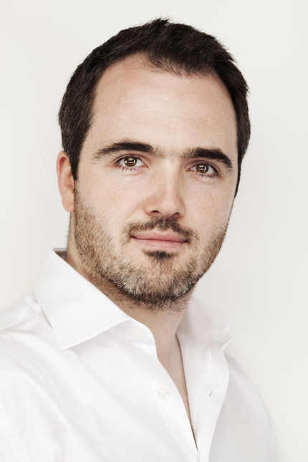
Musical Director - Samuel Evans

Sam Evans is a professional singer, conductor and teacher. He is Music Director of Thomas's Choral Society in Battersea, Artistic Director of Riverside Opera, and has recently been appointed Choral Director at Reading University. He received his early musical education in the choirs of Tiffin School and Kingston Parish Church, and took up a choral scholarship at King’s College Cambridge in 1998. He has sung regularly with the Monteverdi Choir since 2001, and has performed with all the major professional UK choirs, including Polyphony, The Sixteen and the BBC Singers. As a soloist, he trained on the postgraduate singing course at the Royal Academy of Music, and later at the Royal College of Music International Opera School, graduating in 2011 with the prestigious Tagore Gold Medal. Solo engagements have included Mozart Requiem at the Royal Albert Hall, Handel Messiah in Norway, and Bach Christmas Oratorio at Sydney Opera House. He has given solo recitals at the Wigmore Hall and St. John's Smith Square, and performed principal operatic roles at the Opéra Comique in Paris, the BBC Proms and the London Handel Festival. He teaches singing Westminster School and Queen Anne’s Caversham, and for the Eton Choral Courses and the National Youth Choir of Great Britain.

